# Unitopia Global — Website Full Guide (with Visuals & Links)

This document provides a complete set of instructions, annotated visuals (to be inserted), and ready-to-use destination content for Unitopia Global’s website redevelopment. It also includes clickable social media links, and clearly marks cancelled features.

## A logo on a black background AI-generated content may be incorrect.1. Homepage

• Change the image to Unitopia Global logo 🡪   
• Replace hero stock image with Unitopia Global logo overlay.  
• Improve CTA button design (hover states, modern look).  
• CANCELLED: Discord community link — 🚫 DO NOT IMPLEMENT.

## 2. About Us Page



• Current design looks unfinished due to repeated seal logo.  
• Replace with authentic visuals: consultant photos, student success images, or infographics.

+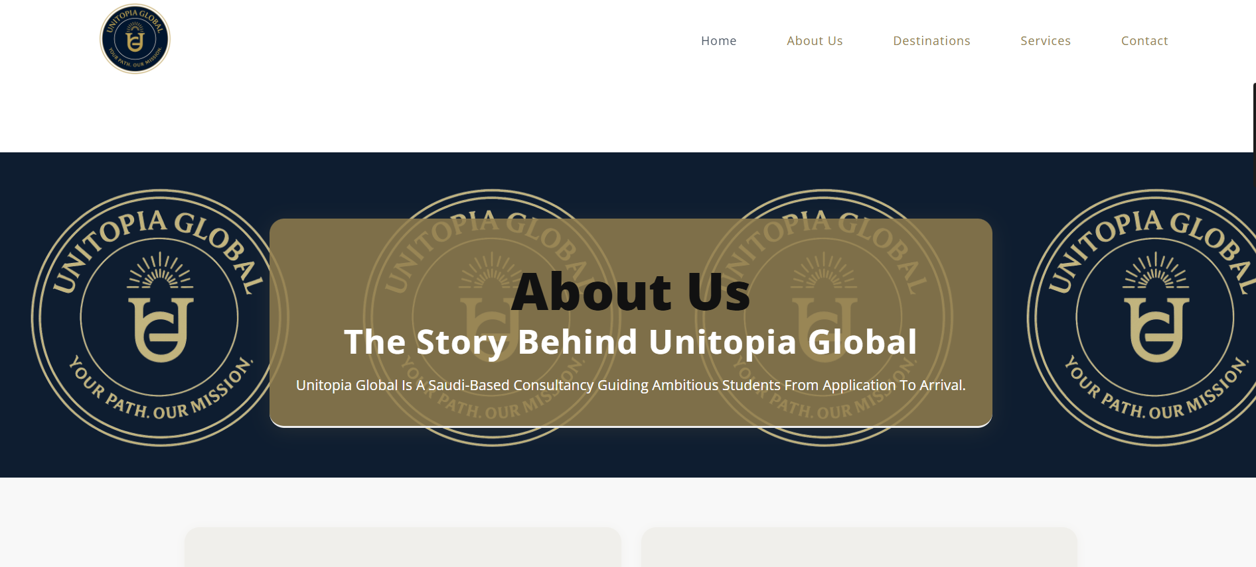

## 3. Services Page

• Redesign service cards inspired by Elite Education.  
• Add hover interactions (scale, shadow, icon animation).  
• Services to highlight: Application, Accommodation, Consultation, Visa & Pre-Departure, Scholarships. Reference: <https://eliteducation.co.uk/>

## 4. Destinations

• Implement mega menu dropdown (IDP-style) listing all countries. <https://www.idp.com/saudiarabia/>   
• Each destination page follows the same structure: Intro, Educational Excellence, Student Opportunities, Lifestyle, Popular Universities, How Unitopia Helps.  
• CANCELLED: Ambassador Program — 🚫 DO NOT IMPLEMENT.

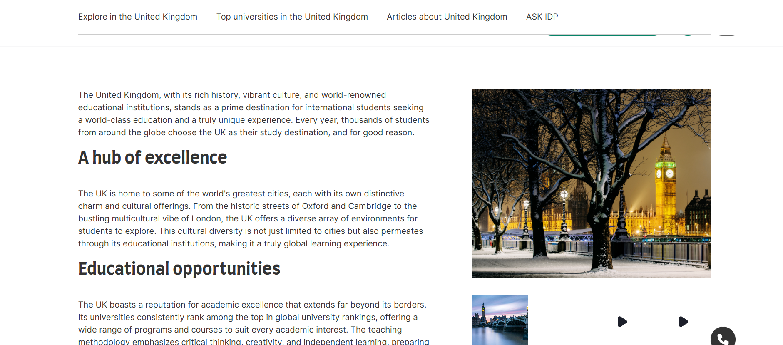  
  
Section Title: Why Study Abroad? (above features study destinations)

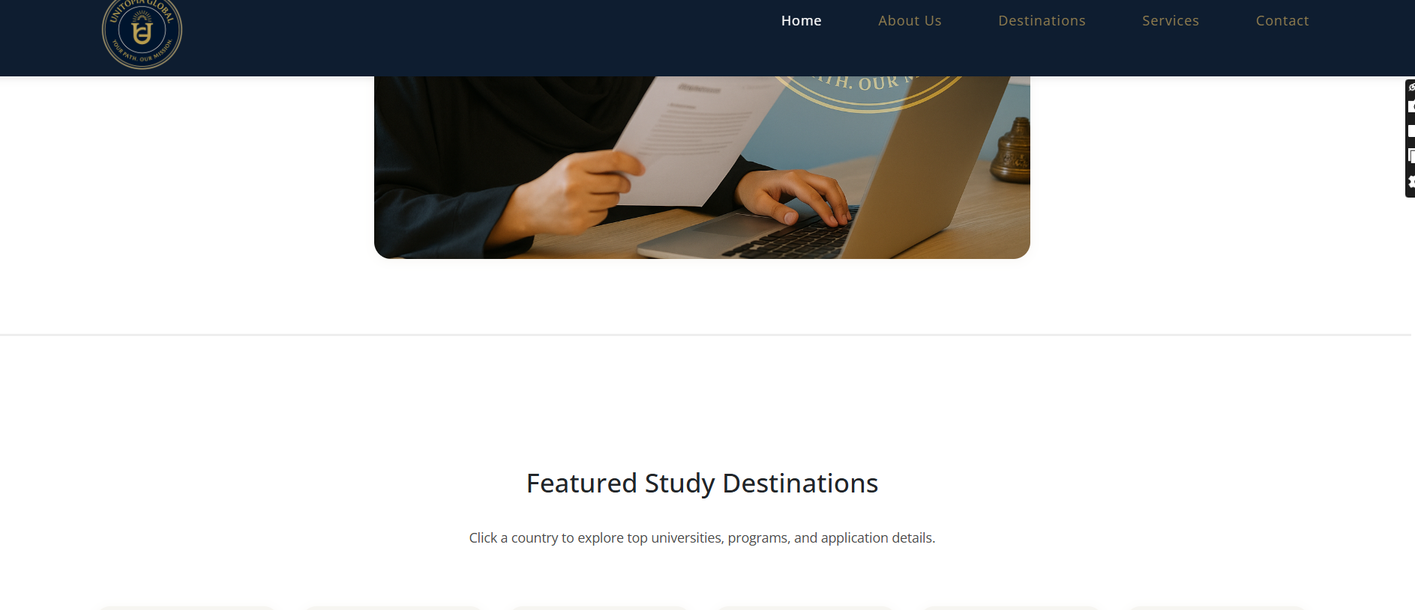



Box 1: 🌍 Global Networking

Benefit: Build lifelong connections with classmates, professors, and professionals from around the world.

Impact: Creates a powerful international network that helps with future career and business opportunities.

Box 2: 🌐 Cultural Adaptation

Benefit: Live and learn in a new culture, gaining adaptability and resilience.

Impact: Employers value graduates who can work across cultures and thrive in global environments.

Box 3: 💼 International Opportunities

Benefit: Access to internships, research, and post-study work visas abroad.

Impact: Increases career prospects and opens doors to global job markets.

Box 4 (optional): 🎓 World-Class Education

Benefit: Learn from top-ranked universities and cutting-edge programs.

Impact: Gain a degree that’s respected worldwide and boosts credibility.

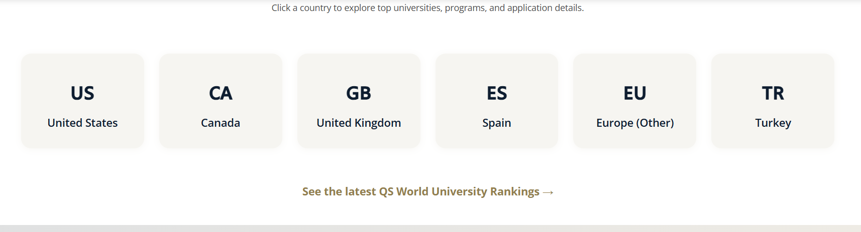  
Change to USA, Canada, UK, Spain, Netherlands, and Australia.



Also, add above the QS rankings, “Can’t find the destination you’re looking for? Contact us!”

Add a circle flag on each box as well, and add under:  
 USA   
150+ universities  
CANADA  
20+ universities  
UK

200+ universities

Netherlands

15+ universities

Australia

150+ universities

### 4.1 Destinations Page Hierarchy Destinations ├── United Kingdom (info) ├── Canada (info) ├── USA (info) ├── Spain (info) ├── Netherlands (info) ├── Australia (info) └── Cyprus (info)

### United Kingdom

**Introduction**  
The United Kingdom combines centuries of academic tradition with modern innovation. Home to some of the world’s most prestigious universities, the UK attracts international students seeking high-quality education, cultural diversity, and global career opportunities.

**Educational Excellence**  
UK universities are globally recognized for their research, critical-thinking approach, and academic rigor. Degrees are specialized and often shorter than in other countries, saving students both time and cost.

**Student Opportunities**  
The UK’s Graduate Route visa allows eligible graduates to stay and work after completing their studies, providing a strong pathway into professional careers.

**Lifestyle & Culture**  
The UK offers vibrant student life in cities like London, Manchester, and Edinburgh. While London is premium, many smaller cities provide more affordable living with the same high-quality education.

**Popular Universities**

* University College London (UCL)
* London School of Economics (LSE)
* University of Manchester
* King’s College London
* University of Edinburgh

**How Unitopia Helps**  
Unitopia Global supports students with personalized planning, applications, visa assistance, and pre-departure orientation, ensuring a smooth academic journey in the UK.

### United States

**Introduction**  
The United States is one of the most popular destinations for international students, offering unmatched diversity, flexible study options, and a world of opportunities across all fields of study.

**Educational Excellence**  
American universities are leaders in research, innovation, and technology. Students benefit from flexible curricula, allowing them to explore multiple disciplines before specializing.

**Student Opportunities**  
Optional Practical Training (OPT) allows international students to gain work experience after graduation, with STEM graduates eligible for extended opportunities.

**Lifestyle & Culture**  
The US offers a multicultural environment, from vibrant cities like New York and Los Angeles to traditional college towns. Costs vary widely depending on location and university.

**Popular Universities**

* Harvard University
* Massachusetts Institute of Technology (MIT)
* Stanford University
* University of California, Berkeley
* Columbia University

**How Unitopia Helps**  
From selecting the right program to visa support and scholarship guidance, Unitopia Global helps students unlock opportunities across the US higher education system.

### Canada

**Introduction**  
Canada is a top choice for international students, offering excellent education, affordable tuition compared to other English-speaking countries, and a welcoming multicultural environment.

**Educational Excellence**  
Canadian universities consistently rank among the best globally, with strong programs in engineering, medicine, business, and technology. Many programs emphasize practical experience.

**Student Opportunities**  
Canada’s Post-Graduation Work Permit (PGWP) allows graduates to gain valuable work experience and can be a pathway to permanent residency.

**Lifestyle & Culture**  
Canada is known for safety, diversity, and high quality of life. Major student hubs include Toronto, Vancouver, and Montreal, each offering unique cultural and academic opportunities.

**Popular Universities**

University of Toronto

McGill University

University of British Columbia (UBC)

University of Alberta

McMaster University

**How Unitopia Helps**  
We provide tailored guidance on choosing universities, preparing applications, securing scholarships, and navigating Canada’s student visa system.

### Spain

**Introduction**  
Spain combines a rich cultural heritage with growing recognition in higher education. It is increasingly popular for students who want a European experience at a more affordable cost.

**Educational Excellence**  
Spanish universities are known for strong programs in business, humanities, and sciences. Many universities now offer English-taught degrees, making Spain more accessible to international students.

**Student Opportunities**  
Internship programs and EU exchange opportunities help students gain professional experience. Spain also offers a post-study residence option for graduates.

**Lifestyle & Culture**  
Spain offers a relaxed lifestyle, Mediterranean climate, and affordable cost of living. Cities like Madrid, Barcelona, and Valencia are vibrant student hubs with international communities.

**Popular Universities**

University of Barcelona

Complutense University of Madrid

Pompeu Fabra University

Autonomous University of Madrid

IE Business School

**How Unitopia Helps**  
Unitopia Global assists with admission to English-taught or Spanish-taught programs, visa applications, and housing support for a smooth transition.

### Netherlands

**Introduction**  
The Netherlands is one of Europe’s most innovative education hubs, offering globally ranked universities and a wide range of English-taught programs.

**Educational Excellence**  
Dutch universities are known for research excellence, especially in engineering, social sciences, and business. Programs emphasize critical thinking and international collaboration.

**Student Opportunities**  
Graduates can benefit from the Orientation Year visa, which allows them to stay in the Netherlands for one year to seek employment.

**Lifestyle & Culture**  
The Netherlands is safe, well-connected, and multicultural, with cities like Amsterdam, Rotterdam, and Utrecht offering lively student environments. Cycling culture and affordable public transport make living easy.

**Popular Universities**

University of Amsterdam

Delft University of Technology

Erasmus University Rotterdam

Utrecht University

Leiden University

**How Unitopia Helps**  
We guide students through selecting top programs, preparing strong applications, and managing visas, scholarships, and accommodation.

### Australia

**Introduction**  
Australia is a global study destination, known for high-quality education, diverse student communities, and strong career opportunities after graduation.

**Educational Excellence**  
Australian universities rank among the top globally, with strengths in medicine, engineering, environmental science, and business. Many programs include industry placements.

**Student Opportunities**  
Graduates are eligible for Temporary Graduate visas, allowing them to gain work experience in Australia. Strong links to Asia-Pacific industries also open career doors.

**Lifestyle & Culture**  
Australia offers safe, multicultural cities such as Sydney, Melbourne, and Brisbane. Students enjoy a high standard of living, with beaches, cultural events, and nature close by.

**Popular Universities**

University of Melbourne

Australian National University (ANU)

University of Sydney

University of Queensland

Monash University

**How Unitopia Helps**  
Unitopia Global provides support for applications, visas, scholarships, and settling into Australia, ensuring students feel confident in their transition.

### Cyprus

**Introduction**  
Cyprus is an emerging destination for international students, offering affordable tuition fees, English-taught programs, and a safe Mediterranean environment.

**Educational Excellence**  
Cypriot universities are gaining international recognition, with strong programs in business, medicine, tourism, and engineering. Many institutions partner with UK and EU universities.

**Student Opportunities**  
Cyprus provides practical internships, exchange opportunities, and pathways to continue studies in other EU countries.

**Lifestyle & Culture**  
Students enjoy a warm climate, beautiful coastlines, and a welcoming culture. The cost of living is lower than in many European countries, making it a budget-friendly choice.

**Popular Universities**

University of Cyprus

Cyprus University of Technology

European University Cyprus

University of Nicosia

Frederick University

**How Unitopia Helps**  
We help students access affordable study options, navigate visa requirements, and secure accommodation for a comfortable stay.

## 5. Footer & Social Media

• Add clickable social links with icons.  
• Locations: Riyadh, Amman, London.

TikTok: <https://www.tiktok.com/@unitopiaglobal>

Instagram: <https://www.instagram.com/unitopiaglobal>

Facebook: <https://www.facebook.com/share/16nL5m5QpC/?mibextid=wwXIfr>

LinkedIn: <https://www.linkedin.com/company/unitopia-global/>

## 6. Contact us section

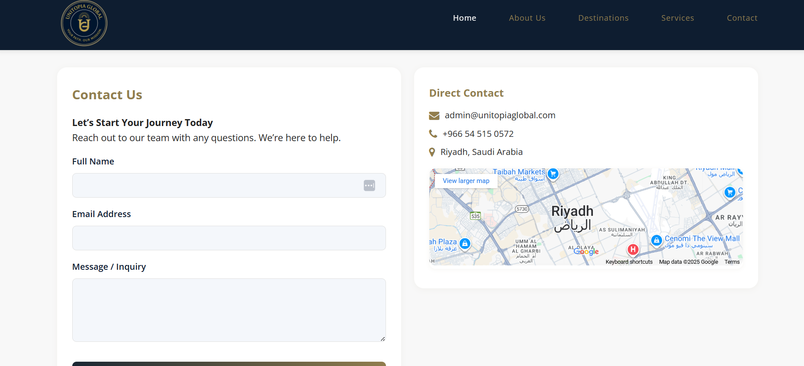  
  
Cancel the location, as we said before, and change the form here to:  
• **Full Name**



Sub page for faq’s



• **Email**

• **Phone (WhatsApp preferred)**

• **Current School / Grade**

• **Intended Major / Field of Study**

• **Destination Country** *(dropdown: UK, USA, Canada, Spain, Turkey, Netherlands, Other)*